**DBS Lab 4**

10 select statement Querries

1. Retrieves all information of customer from the Customers table where the CustomerID is equal to 6.

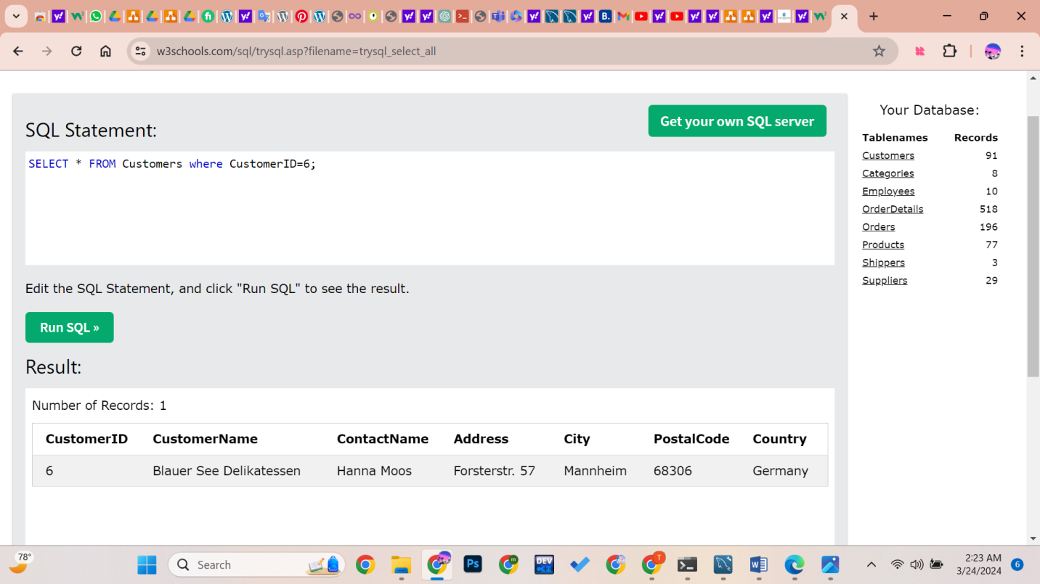

1. Retrieve Employee Names and Birthdates:

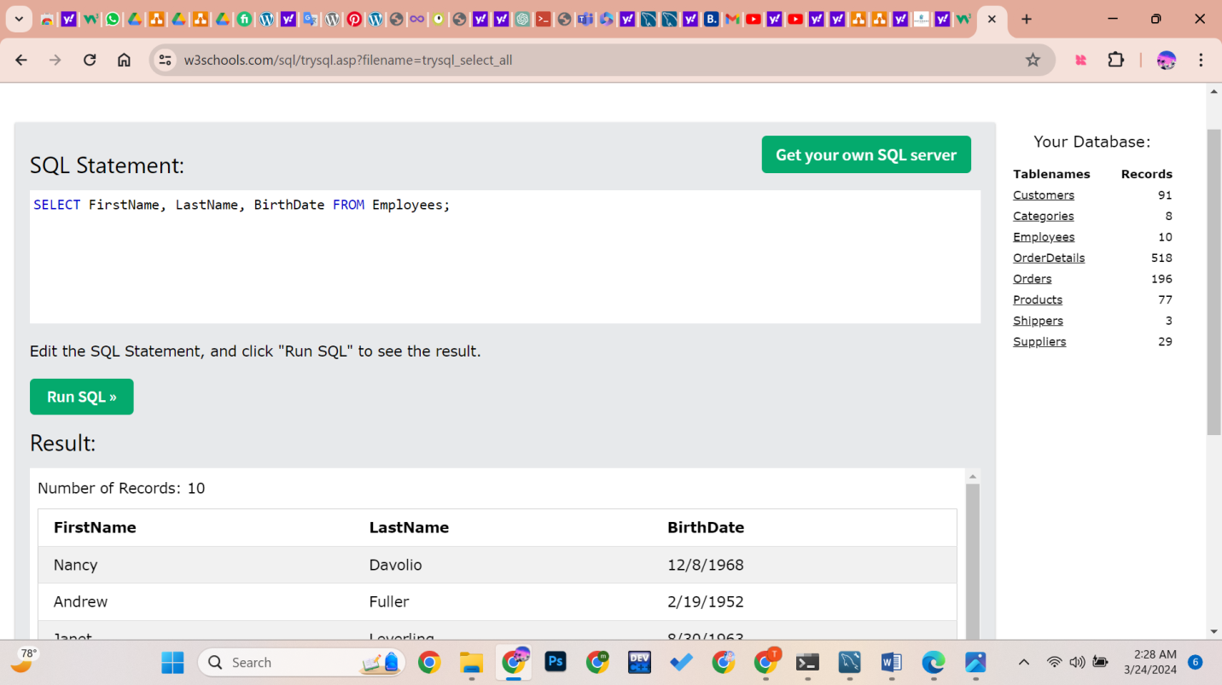

1. Retrieve Employees with Bachelor's Degrees:

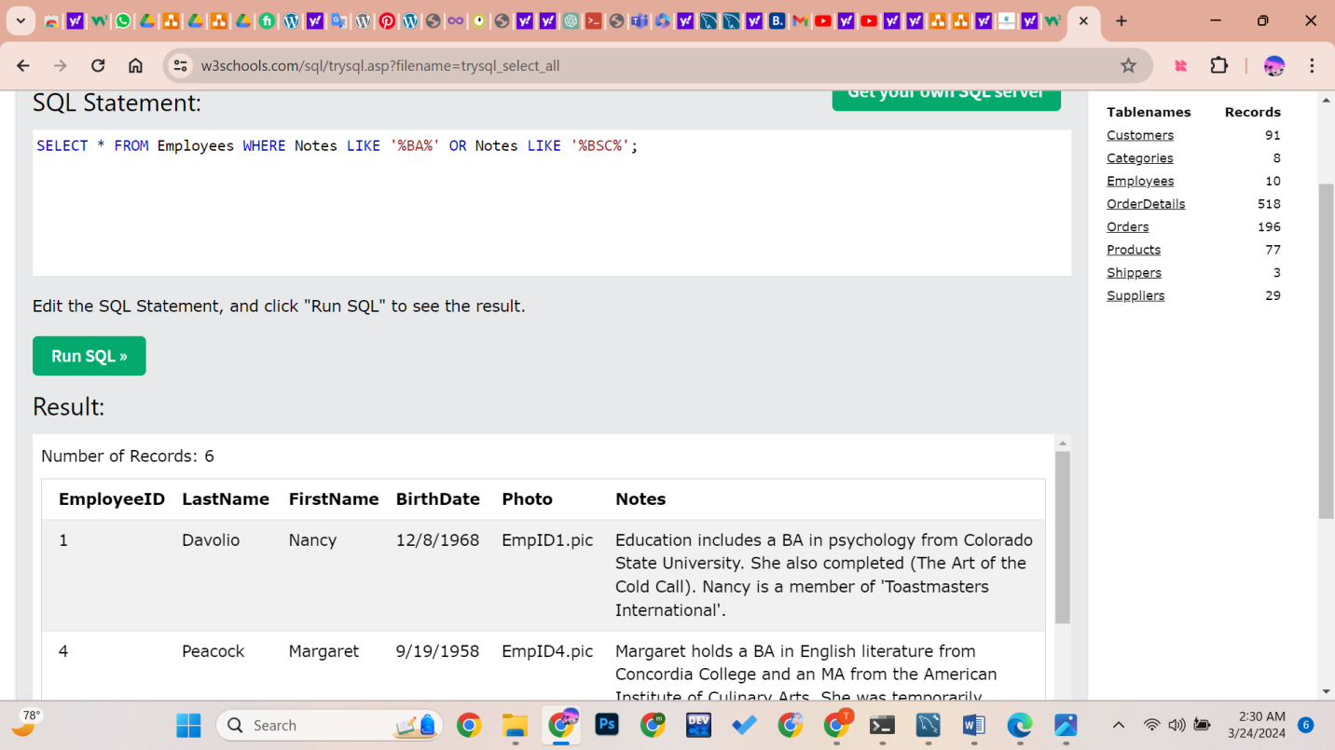

1. Retrieve Employees Born After 1960:

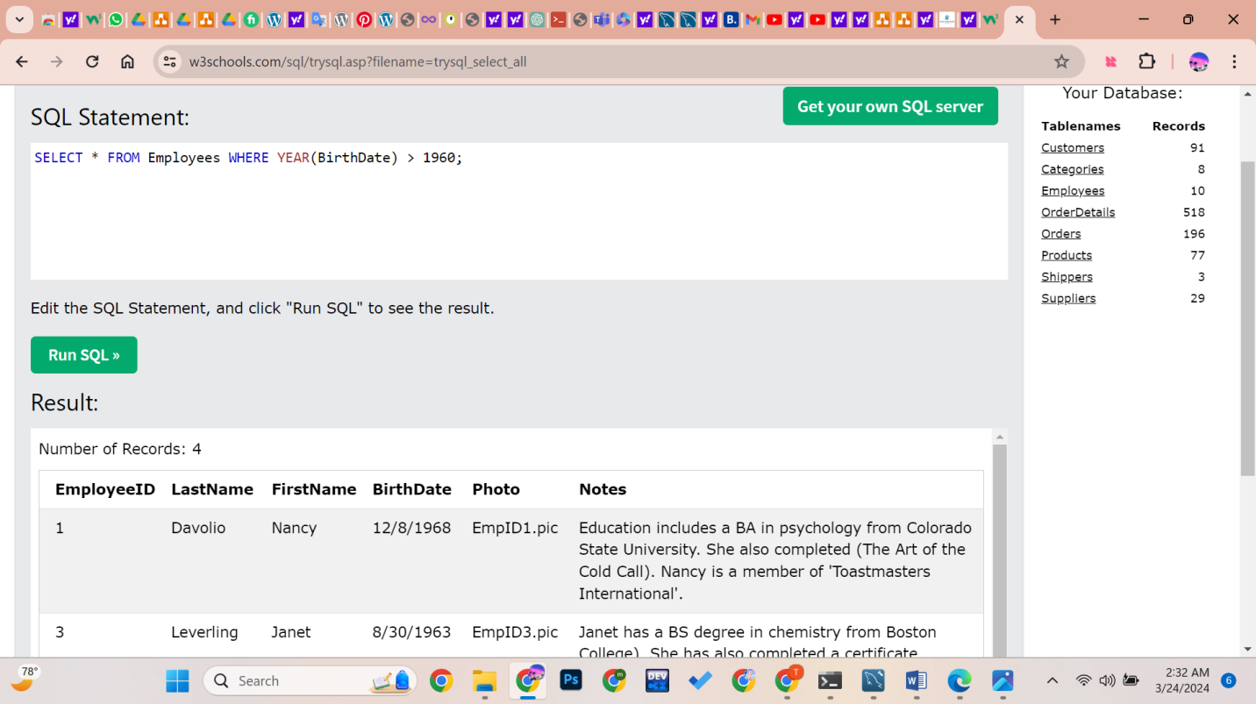

1. Retrieve all customers from France:

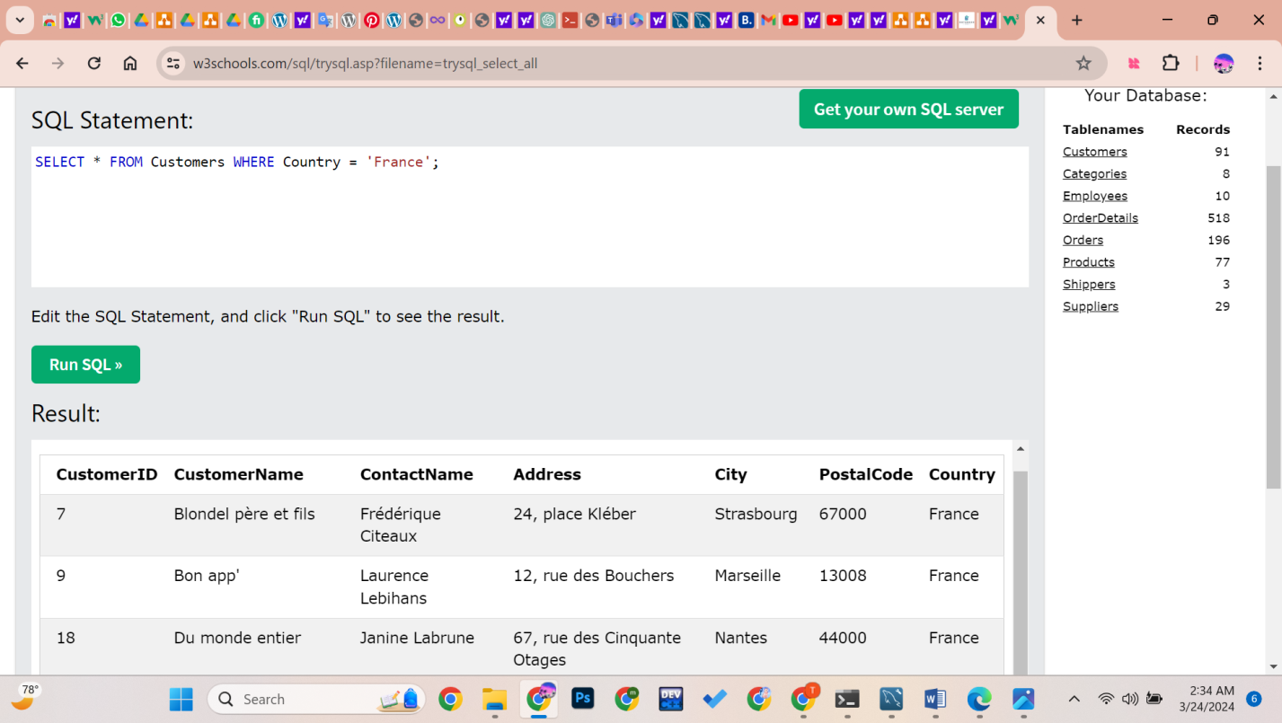

1. Retrieve customers from the UK with postal codes starting with 'WA':

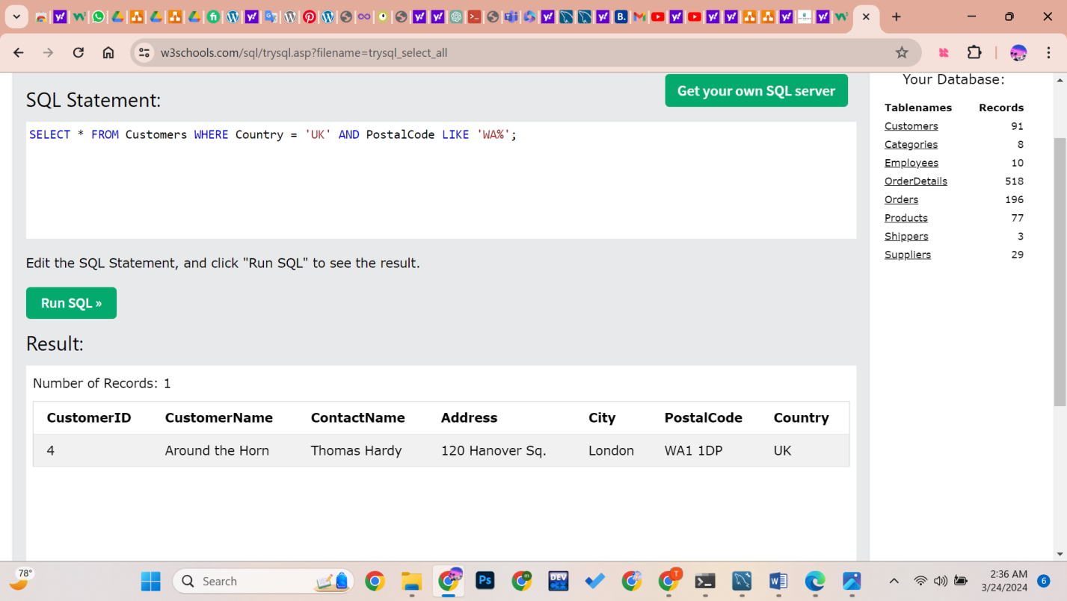

1. Retrieve customers from Germany or Spain:

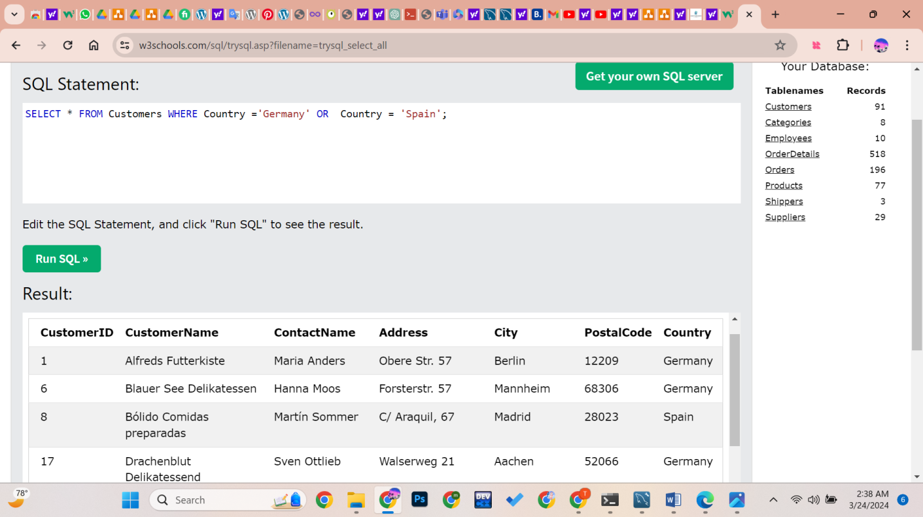

1. Retrieve customers whose name’s second letter is ‘a’:

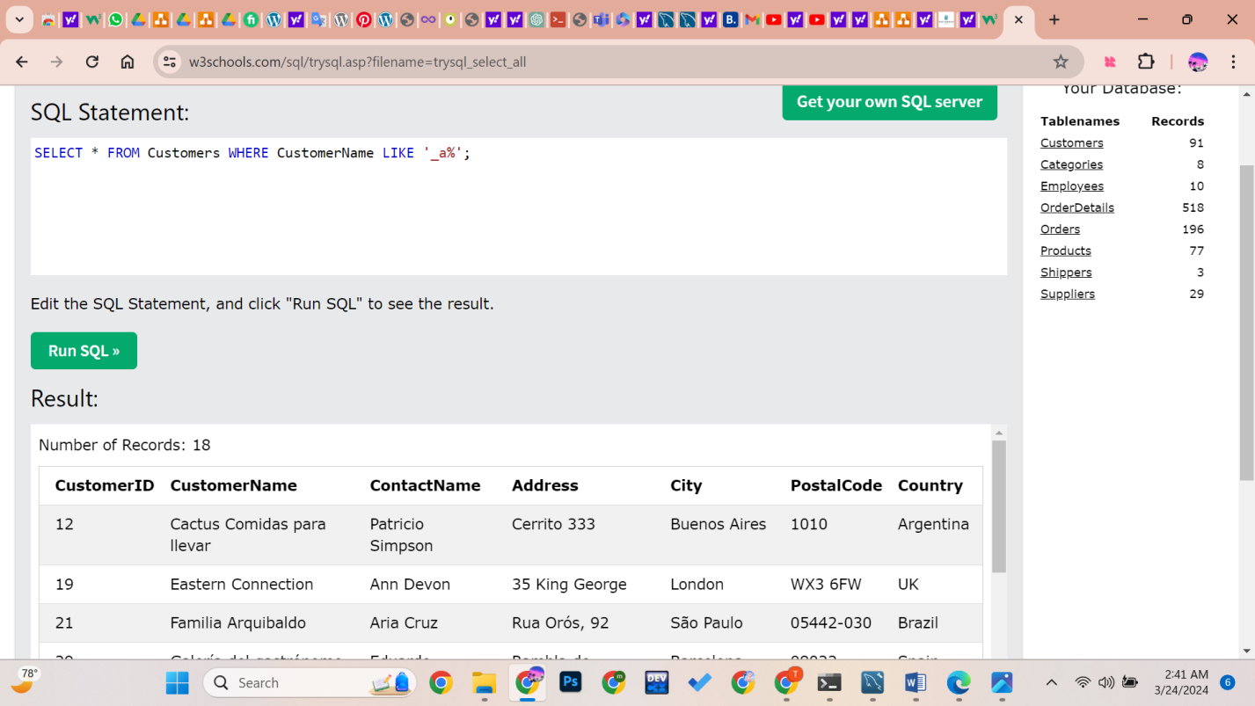

1. Retrieve suppliers from countries with postal codes starting with '5' or '6':

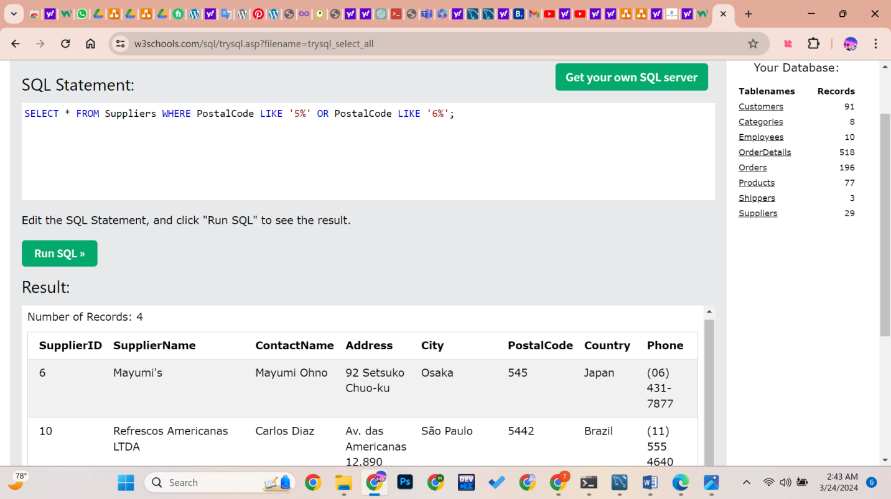

1. Retrieve suppliers whose contact names start with 'N' and are from countries other than the USA:

